April 5, 2016
dana Martin
EENG 517

Modeling and Control of a limited degree of freedom double rotor helicopter

Contents
i. List of Figures i
ii. List of Symbols ii
Part 1: Project Overview 1
Part 2: Modeling of the System 1
Part 2.1: System Definition 1
Part 2.2: Disturbances 4
Part 2.3: Actuators and Sensors 5
Part 3: State Space Representation 5
Part 3.1: Non Linear State Space 5
Part 3.2: Simulation of the Nonlinear system in MATLAB/Simulink 5
Part 3.3: Linearization 6
Part 3.4: Controllability and Observability 8
Part 3.5: Transfer Matrix 9
Part 4: Control System Design 10
Part 4.1: State Feedback Controller 10
Part 4.2: Single Input Single Output Control 10
Part 4.2: State Feedback Controller 12
References 13
Appendix 14
A.1-Simulation of the nonlinear model in Simulink 14
A.1-Calculation of Equilibrium inputs 15
Raw Figures 16
Mistakes / Extra Work 17

List of Figures
Figure 1 – Vertical axis orientation w.r.t helicopter fuselage and main rotor
Figure 2 – Moment location and tail rotor thrust vector location
Figure 3 – Blade feathering diagram and axis location
Figure 4 – Block diagram showing lift force input/output dependencies
Figure 5 – Block diagram showing moment input/output dependencies
Figure 6 – Overall block representation of MIMO system
Figure 7 – Output response of nonlinear system
Figure 8 – Jacobian of A
Figure 9 – SISO Controller showing tracking of a step input
Figure 10 – Tuned SISO Controller showing tracking of a step input

List of Symbols
β – Rotor blade flapping angle
$α_{1}$,$α_{0}$ $β_{2}$,$β_{1}$, $β_{0}$ – Coefficients of SISO controller
ϴ – Rotor blade pitch angle
c – Chord length of airfoil
C_{L} – Lift coefficient of airfoil
C_{D,F} – Drag coefficient of fuselage
N_{M} – Number of rotor blades on main rotor
N_{T} – Number of rotor blades on tail rotor
A_{M} – Area of main rotor blade
A_{T} – Area of tail rotor blade
A_{F} – Area of fuselage
a_{L} – Linearized lift coefficient slope for rotor blades
a_{D} – Linearized drag coefficient slope for helicopter fuselage
F_{L} – Aerodynamic lift force
Ω_{M} – Main rotor rotational speed
r_{T} – Radius of tail rotor blade
r_{M} – Radius of main rotor
Ω_{T} – Tail rotor rotational speed
D_{T} – Horizontal distance from the center of gravity to tail rotor
M_{F} – Mass of helicopter fuselage
$∆m$ – Disturbance in the mass of the fuselage
M_{B} – Mass of main rotor blade
I_{B} – Rotational inertia of main rotor blade about the pitch axis
Z – Helicopter’s height from a reference point
$\dot{Z}$ - Helicopter’s velocity in the vertical direction
$\ddot{Z}$ – Helicopter’s acceleration in the vertical direction
R – Yaw position of a helicopter from a reference point
$\dot{R}$ – Yaw rate of the helicopter
$\ddot{R}$ – Yaw acceleration of helicopter
g – Gravitational constant (9.81 m/s²)
$ρ_{air}$ – Density of air at STP
AR – Aspect ratio
$δx$ – Perturbation of x from its equilibrium value
$δu$ – Perturbation of input u from its equilibrium value
$δy$ – Perturbation of output y from its equilibrium value

Part 1: Project Overview
A system is defined as a set of interconnected components working together to accomplish a common goal. With the complexity of modern day technology increasing, systems are becoming more intricate with every passing day. Often times, a team of multidisciplinary engineers are responsible for the design and implementation of the system, with individual parts (or subsystems) being designed separately, to be integrated a later date. This means that the knowledge and know-how of how the system works is scattered throughout a large group of people from different backgrounds. This makes the task of ensuring that the system functions properly and optimally are also difficult tasks.
The goal of this project is exactly that: Choose a system with multiple inputs and multiple outputs (MIMO), model the system defining its inputs, outputs, state variables, disturbances and design a controller to optimize its functionality. There are many preliminary and intermediate steps encompassed in the design and implementation of a control system. For example: system definition, system modeling, control system selection, pole placements, control system performance, etc. which will all be investigated in sections to come. The report will be organized in the following manner.
In Section 2 the system will be defined and modeled. Constants, state variables, inputs, outputs, and disturbances will be defined and shown using differential equations and block diagrams.
In Section 3 the state space representation will be developed for the nonlinear system followed by a linearization procedure allowing the system to be described through a LTI state space representation.

Part 2: Modeling of the System

Part 2.1: System Definition
The initial step in the designing a controller is to define the system. In other words, what aspects can be controlled, what aspects will be measured and how will they relate to one another. The system of interest is a double rotor helicopter with limited degrees of freedom (DOF) in hover. The main rotor will consist of two blades and have a fixed angular velocity with varying pitch angles. The tail rotor will be a fixed pitch, zero flapping angle, and will have a varying angular velocity. The helicopter will be free to move in vertical direction (denoted by z) and rotate with a moment about the z axis (denoted by R). This translates to the helicopter having freedom in the vertical direction and yaw movement.

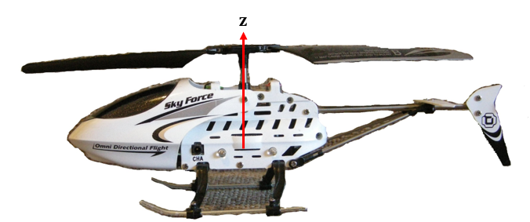
Figure 1-Vertical axis orientation with respect to helicopter fuselage
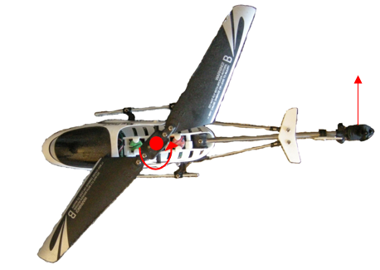
Figure 2-Top View of helicopter showing moment axis

From the above description, it can be seen that the state variables of interest are Z,$\dot{Z}$, $\ddot{Z}$, and R, $\dot{R}$, $\ddot{R}$. How will these “states” be controlled? For the main rotor, it will rotate at a constant angular velocity, and in order to change the aerodynamic lift force (F_{L}) generated by the rotor the collective pitch angle (ϴ) will be varied using actuators at the hub connection.

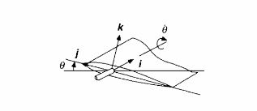
Figure 3-Blade Feathering diagram [3]
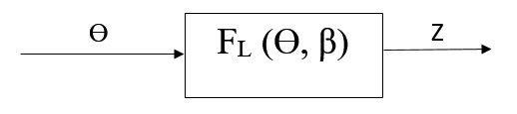
Figure 4-Lift force dependencies and output

Figure 1 above shows a section of one of the rotor blades, illustrating the orientation and axis location for the pitch angle $(θ)$ input parameter. In the figure, the angular velocity of the rotor blade, but it can be imagined to be in an arc in which the $\hat{j}$ vector is tangent to its path. Since the rotor has a fixed rotational speed, the aerodynamic lift force must be varied by changing the collective pitch angle of the rotor blades. The lift coefficient (C_{L}) is a nonlinear function of $θ$ and will be simplified to a linear form in subsequent sections. To calculate the relationship between the above input and output variables, free body diagrams are used to sum forces and moments in specified directions.
Summing the forces in the vertical direction of the fuselage/rotor system an equation relating the pitch angle to the fuselage’s motion is shown below.
${N*C}_{L}\left(θ\right)\left[\frac{1}{2}ρ_{air}{\left(Ω_{M}r_{M}\right)}^{2}A_{M}\right]-M_{F}g={(M}_{F}+∆m)\ddot{Z}-C_{D,F}\left[\frac{1}{2}ρ_{air}\dot{Z}A_{F}\right]$ Eq. 1
Where,
$C_{L}\left(θ\right)=2π*sin\left(θ\right)$ Eq. 2
Note: Some components of Equation 1 were derived from characteristics of fixed wing aircraft, leading to some inaccuracies in the calculation of forces in the system.
Equation 1 is a nonlinear equation, which will present some difficulty in the creation of an LTI state-space system. It is not so obvious to see the nonlinearity from the format of the above equation, but from the definition of the lift coefficient, it can be seen the term behaves in a nonlinear manner as $θ$ is increased. One more thing to take notice of in the above equations is the fact that the lift force is written in terms of the helicopter rotor velocity while the drag force is in terms of the fuselage’s velocity. This is due to the fact that the drag force on the blades is assumed to be much smaller than the lift force while the fuselage has a large area, in turn, making the drag force on the fuselage a driving factor for damping in terms of vertical motion. In the sections to come, the equation will be put through a linearization process using some common assumptions and putting constraints on the pitch angle parameter.
Here, the equations and inputs used to determine the yaw position of the helicopter will be developed. The tail rotor will be a constant pitch, variable speed rotor with zero flapping angle. The pitch angle of the main rotor, $θ$, will be coupled with F_{L} while also inducing a yawing moment that will have to be counteracted by the tail rotor, enacted at a distance D_{T} from the main rotor. In the block diagram shown in figure 4, the input and output variables are illustrated.
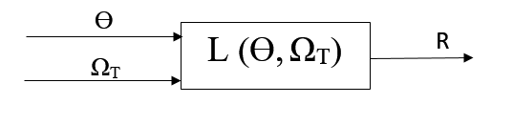
Figure 5-Block diagram showing moment relationship between inputs and outputs
The yawing moment resulting from a change in the blades’ pitch angle is described by Equation 4 shown below.
$I_{B}\dot{θ}+I_{B}Ω_{M}^{2}\sin\left(θ\right)cos⁡(θ)=L_{M}$ Eq. 3
The yawing moment produced by the horizontal tail rotor thrust is described by Equation 5 shown below.
$\left(a_{T}θ_{T}\frac{1}{2}ρ_{air}{\left(Ω_{T}r_{T}\right)}^{2}A_{T}\right)D_{T}=L_{T}$ Eq. 4
Through convention L_{M} = - L_{T}.
There will also be a resistance to angular motion by the fuselage in the form of a drag force. This force can be expressed as:
$\left(C_{D,F}\frac{1}{2}ρ_{air}{\dot{R}}^{2}{2A}_{F}\right)\frac{D_{T}}{6}$ Eq. 5
Now, a few things about the terms in equation 6 above. It can be seen that the drag force acts a distance of $\frac{D_{T}}{6}$ from the center of gravity. This distance is highly dependent on the geometry of the fuselage and can vary drastically from one design to the next, but for the purposes of this project that is where the drag force will be assumed to live. Also, it can be seen that the area of the fuselage is multiplied by 2. The A_{F} term is the cross sectional area of the fuselage from the front, and for the drag force the cross sectional area of concern is the area from the side perspective, which is usually much greater because a fuselage is designed to be aerodynamically contoured for forward flight, and this is a conservative approximation. Last, the drag force moment will act against the direction of yaw motion.
Therefore, the total moment on the helicopter fuselage is described by Equation 6.
$L_{T}-L_{M}=I_{F}\ddot{R}-\left(C_{D,F}\frac{1}{2}ρ_{air}{\dot{R}}^{2}{2A}_{F}\right)\frac{D_{T}}{6}$
$\left[\left(C_{L}(θ)\frac{1}{2}ρ_{air}{\left(Ω_{T}r_{T}\right)}^{2}A_{T}\right)D_{T}\right]-\left[I_{B}\dot{θ}+I_{B}Ω_{M}^{2}\sin\left(θ\right)cos⁡(θ)\right]=I_{F}\ddot{R}-\left(C_{D,F}\frac{1}{2}ρ_{air}{\dot{R}}^{2}{2A}_{F}\right)\frac{D_{T}}{6}$ Eq. 6
The two nonlinear equations of motion that will be used in the formation of the state space system are:
${N*C}_{L}\left(θ\right)\left[\frac{1}{2}ρ_{air}{\left(Ω_{M}r_{M}\right)}^{2}A_{M}\right]-M_{F}g={(M}_{F}+∆m)\ddot{Z}-C_{D,F}\left[\frac{1}{2}ρ_{air}\dot{Z}A_{F}\right]$ Eq. 7
$\left[\left(C_{L}(θ)\frac{1}{2}ρ_{air}{\left(Ω_{T}r_{T}\right)}^{2}A_{T}\right)D_{T}\right]-\left[I_{B}\dot{θ}+I_{B}Ω_{M}^{2}\sin\left(θ\right)cos⁡(θ)\right]=I_{F}\ddot{R}-\left(C_{D,F}\frac{1}{2}ρ_{air}{\dot{R}}^{2}{2A}_{F}\right)\frac{D_{T}}{6}$ Eq. 8
The above two equations include the state variables $\overline{Z}$ & $\overline{R}$ along with input variables $θ$ & $Ω_{T}$. All other variables in the equations are given because their values are inherent properties of the system. Where
State Variables Input Variables Output Variables Disturbances
$\left(\begin{matrix}Z \\ \dot{Z}\end{matrix}\right)$ $θ$ $Z$ $∆m$
$\left(\begin{matrix}R \\ \dot{R}\end{matrix}\right)$ $Ω_{T}$ $R$
From the definition of the state variables above, some possible objectives of the controller could be to maintain a certain position and change positions within a specified time frame.
An overall block diagram representing the system, or “PLANT”, with input and output variable relationship described above is shown below. The PLANT is represented by the dashed line with the individual components operating within the plant are shown in solid line boxes.
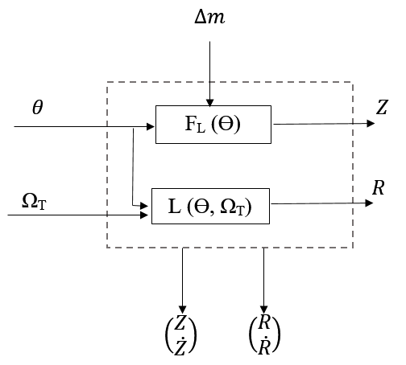
Figure 6-Overall block representation of MIMO system

Part 2.2: Disturbances
In section 2.1, an overall nonlinear system was defined, equations of motion were developed and coupled. Systems operating in real world conditions are often effected by extraneous conditions that cannot be controlled or even for seen, but can be accounted for in the design of the controller. Our helicopter model is extremely simplified; with only 2 DOF, in hover and very little coupling of motion, but it is also of interest that the controller be able to respond to a change in mass. For example, if the helicopter were needed to install a new rotor on an extreme scale wind turbine, it would need to hover in a specified location given two different masses, i.e. a total mass including the mass of the rotor and one without, when the payload had been delivered. Since the helicopter is only allowed to translate in a vertical direction and yaw around that axis, the increase or decrease in mass will be assumed to be in line with the fuselage’s center of gravity, and therefore, will not induce any rolling or pitching motion.

Part 2.3: Actuators and Sensors
For the system to change its states there must be pieces of the system that are measured. For the sake of this project, actuator and sensor characteristics will be simply modeled if not neglected entirely. To measure the height and yaw of the helicopter a GPS device could be used that would triangulate the position in the z-direction and use a magnetic reference to calculate the yaw position. Another option for measuring height is to use a barometer, although in our model development we are assuming constant density and therefore would not be so applicable.

Part 3: State Space Representation

Part 3.1: Non Linear State Space
Equation 7 is nonlinear in $θ$ and Equation 8 is nonlinear in $θ$ & R. Here the state space representation will be developed in terms of the nonlinear equations from above. The general form for state space equations is:
$\dot{x}=Ax+Bu$+Γ_{D} Eq. 9
$y=Cx+Du$ Eq. 10
where A, B, C, D and Γ_{D} are matrices. The disturbance matrix denoted by Γ_{D} will be developed in later sections. By defining the following state variables, the second order differential equations can be transformed into a set of first order equations in state space.
$x_{1}=Z$ ${\dot{x}}_{1}=\dot{Z}=x_{2}$
$x_{2}=\dot{Z}$ ${\dot{x}}_{2}=\ddot{Z}=\frac{{N*C}_{L}\left(u_{1}\right)\left[\frac{1}{2}ρ_{air}{\left(Ω_{M}r_{M}\right)}^{2}A_{M}\right]-M_{F}g+C_{D,F}\left[\frac{1}{2}ρ_{air}x_{2}A_{F}\right]}{{(M}_{F}+∆m)}$
$x_{3}=R$ ${\dot{x}}_{3}=\dot{R}=x_{4}$
$x_{4}=\dot{R}$ ${\dot{x}}_{4}=\ddot{R}=\frac{\left[\left(C_{L}(u_{1})\frac{1}{2}ρ_{air}{\left(u_{2}r_{T}\right)}^{2}A_{T}\right)D_{T}\right]-\left[I_{B}{\dot{u}}_{1}+I_{B}Ω_{M}^{2}\sin\left(u_{1}\right)\cos\left(u_{1}\right)\right]+\left(C_{D,F}\frac{1}{2}ρ_{air}x_{4}^{2}{2A}_{F}\right)\frac{D_{T}}{6}}{I_{F}}$
With the inputs defined as
$\left(\begin{matrix}u_{1} \\ u_{2}\end{matrix}\right)=\left(\begin{matrix}θ \\ Ω_{T}\end{matrix}\right)$

Part 3.2: Simulation of the Nonlinear system in MATLAB/Simulink
The above nonlinear system was simulated using the Simulink toolbox in MATLAB. Diagrams of the system and subsystems are shown in Appendix A.1.
In order to test the BIBO stability of the nonlinear system, initial conditions of 0 were assumed and unit steps were used as inputs. Using a scope, the response of the output was observed for various values of inputs.

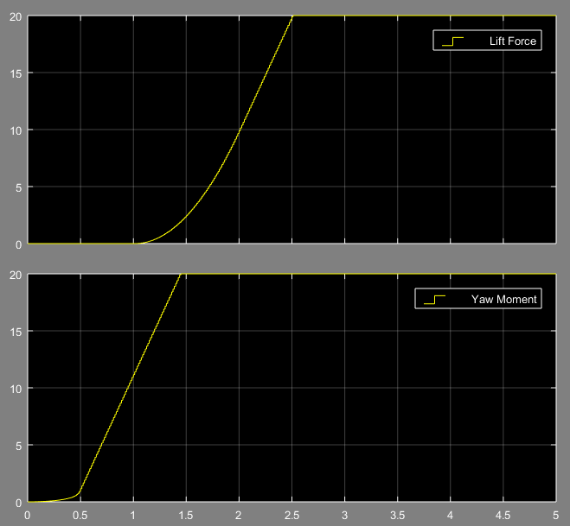
Figure 7.1-Output for $θ=0.0005$ and $Ω_{T}=0.5$
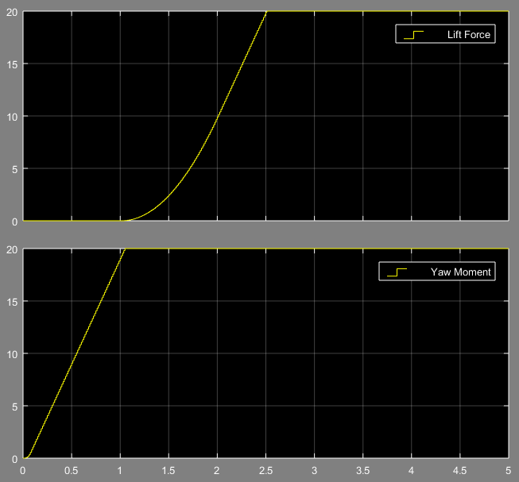
Figure 7.2-Output for $θ=0.005$ and $Ω_{T}=1$

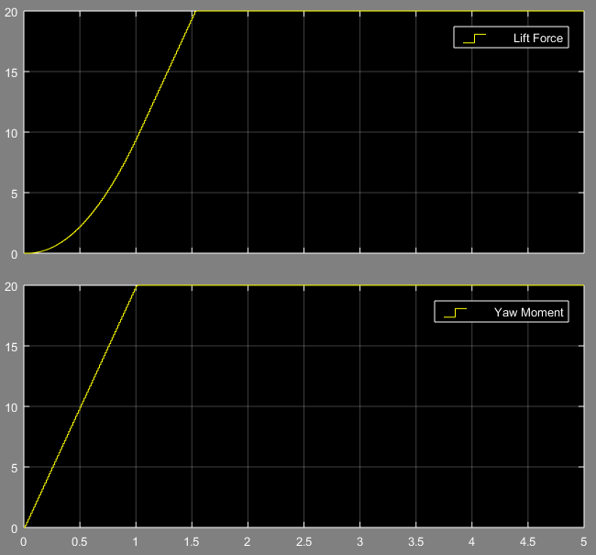
Figure 7.3-Output for $θ=0.05$ and $Ω_{T}=1.5$
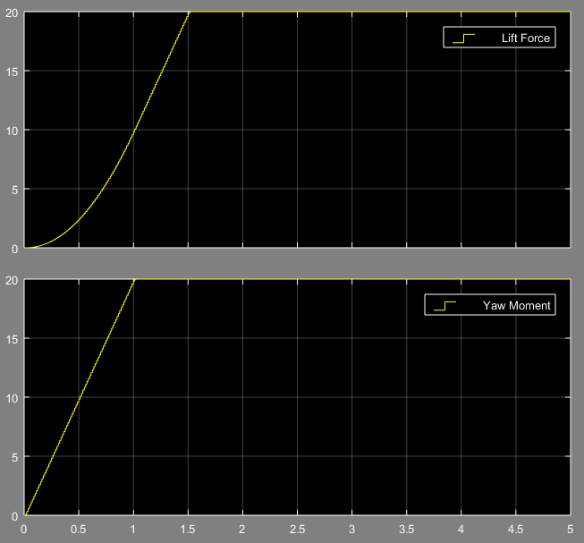
Figure 7.4-Output for $θ=0.5$ and $Ω_{T}=2$
It can be seen that for all four cases above the system is not BIBO stable. Granted the output does saturate at an arbitrary value, but this is only the case because of a setting chosen in the Simulink integrator block.

Part 3.3: Linearization
The main objective of the controller for this project is to keep a helicopter in hover, facing a specified direction. In the state of hovering facing a specified direction, the acceleration and velocity components of the upward motion will be 0, along with the yawing velocity and acceleration components. Therefore, at our operating point the values for $\ddot{Z}=\dot{Z}=0$ and $\ddot{R}=\dot{R}=0$. For the vertical position, and yaw direction, some arbitrary elevation and direction can be specified, and for the sake of this project the height considered “equilibrium” will be defined as Z=10m with a yaw value R=5 degrees. The equilibrium values for the inputs will be calculated at a later time, and the equations will be linearized further.
To calculate the equilibrium inputs for the system, residuals were created in Simulink using the velocity and acceleration in the vertical and yawing direction and iterated through until a solution was found. The Simulink model for this is shown in Appendix A.2.
$x_{1,eq}=10m$
$x_{2,eq}=0$
$x_{3,eq}=5 deg$
$x_{4,eq}=0.01$
With equilibrium inputs
$u_{1,eq}=0.08542 rad$
$$u_{2,eq}=-52.66 rpm$$
*note: The negative sign on the second input comes from the pitch angle. In order to induce a moment that balances the moment created by the main rotor the tail rotor will have to spin in the opposite direction as defined as positive. Also, let it be noted that an ideal system would have 0 velocity in the yawing direction at an equilibrium state, but for the sake of making the problem a bit more interesting, it will suffice that the angular velocity of the fuselage is some very small number. Now that the operating points have been established, the linearized system can be built.
${δx}_{1}=Z_{eq}+∆Z$ ${\dot{δx}}_{1}={\dot{x}}_{1}=x_{2,eq}+δx_{2}$
${δx}_{2}={\dot{Z}}_{eq}+∆\dot{Z}$ ${\dot{δx}}_{2}={\dot{x}}_{2}=\frac{{N*C}_{L}\left(u_{1,eq}+δu_{1}\right)\left[\frac{1}{2}ρ_{air}{\left(Ω_{M}r_{M}\right)}^{2}A_{M}\right]-M_{F}g+C_{D,F}\left[\frac{1}{2}ρ_{air}{(x}_{2,eq}{+δx_{2})A}_{F}\right]}{{(M}_{F}+∆m)}$
$δx_{3}=R_{eq}+∆R$ ${\dot{δx}}_{3}=x_{4,eq}+δx_{3}$
${δx}_{4}={\dot{R}}_{eq}+∆\dot{R}$ ${\dot{δx}}_{4}=\frac{\left[\left(C_{L}(u_{1,eq}+δu_{1})\frac{1}{2}ρ_{air}{\left(u_{2,eq}+δu_{2})r_{T}\right)}^{2}A_{T}\right)D_{T}\right]-\left[I_{B}{\dot{u}}_{1,eq}+I_{B}Ω_{M}^{2}{(u}_{1,eq}+δu_{1})\right]+\left(C_{D,F}\frac{1}{2}ρ_{air}{(x_{4,eq}+δx_{4})}^{2}{2A}_{F}\right)\frac{D_{T}}{6}}{I_{F}}$
With the equilibrium inputs defined as
$\left(\begin{matrix}u_{1,eq} \\ u_{2,eq}\end{matrix}\right)=\left(\begin{matrix}0.08542 rad \\ -52.66 rpm\end{matrix}\right)$
From the Linear Systems Theory Book, a LTI set of state space equations can be found using Taylor series expansions about an operating point defined by the pair $\left(x_{eq},u_{eq}\right)$ and some deviation from this reference level represented using $δ$. The resulting state-space equations are shown below.
$\dot{δx}=Aδx+Bδu$, $δy=Cδx+Dδu$ Eq. 11
Where A, B, C and D are defined by the following Jacobian matrices:
$A=\frac{∂f(x^{eq},u^{eq})}{∂x}$, $B=\frac{∂f(x^{eq},u^{eq})}{∂u}$, $C=\frac{∂g(x^{eq},u^{eq})}{∂x}$, $D=\frac{∂g(x^{eq},u^{eq})}{∂u}$
To illustrate the point even further, the Jacobian for matrix A is shown below
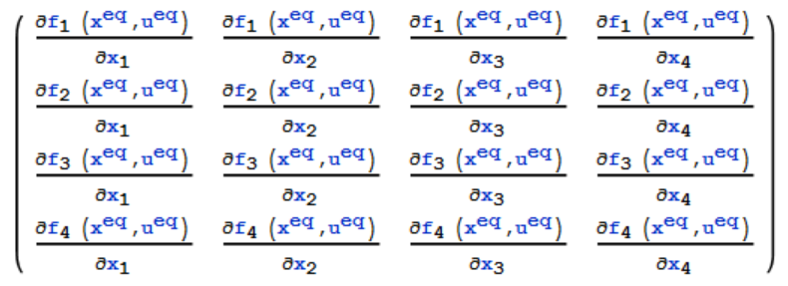
Figure 8-Jacobian of A
Using the technique outlined above, a LTI state space system linearized about the operating points defined above is calculated with the following matrices:
$$\overline{A}=\left(\begin{matrix}0 & 1 & 0 & 0 \\ 0 & \frac{C_{D,F}*0.5*ρ_{air}*A_{F}}{M_{F}} & 0 & 0 \\ 0 & 0 & 0 & 1 \\ 0 & 0 & 0 & \frac{C_{D,F}*ρ_{air}*\frac{D_{T}}{6}*2*0}{M_{F}}\end{matrix}\right)$$
$$\overline{B}=\left(\begin{matrix}0 & 0 \\ \frac{N_{blade}*a_{L}*\frac{1}{2}*ρ_{air}*{(Ω_{m}*r_{m})}^{2}*A_{m}}{M_{F}} & 0 \\ 0 & 0 \\ \frac{a_{L}*\frac{1}{2}*ρ_{air}*-{52.66}^{2}*{r_{T}}^{2}*A_{T}*D_{T}}{I_{F}}-\frac{I_{B}*{Ω_{m}}^{2}}{I_{F}} & \frac{2*a_{L}*\frac{1}{2}*ρ_{air}*52.66*{r_{T}}^{2}*A_{T}*D_{T}}{I_{F}}\end{matrix}\right)$$
$$\overline{C}=\left(\begin{matrix}1 & 0 & 0 & 0 \\ 0 & 0 & 1 & 0\end{matrix}\right)$$
$$\overline{D}=\left(\begin{matrix}0 & 0 \\ 0 & 0\end{matrix}\right)$$
Plugging in values for the above variables, and assuming the solution does not vary with time, the numerical values for the matrix entries are calculated and shown below.
$\overline{A}=\left(\begin{matrix}0 & 1 & 0 & 0 \\ 0 & 24.4 & 0 & 0 \\ 0 & 0 & 0 & 1 \\ 0 & 0 & 0 & 0\end{matrix}\right)$ $\overline{B}=\left(\begin{matrix}0 & 0 \\ 31.6202 & 0 \\ 0 & 0 \\ -20.0001 & 2.7x{10}^{-6}\end{matrix}\right)$
$\overline{C}=\left(\begin{matrix}1 & 0 & 0 & 0 \\ 0 & 0 & 1 & 0\end{matrix}\right)$ $\overline{D}=\left(\begin{matrix}0 & 0 \\ 0 & 0\end{matrix}\right)$

Part 3.4: Controllability and Observability
To ensure a system and the states defined are both controllable and observable (both are necessary properties to ensure that a controller can be built for the system), the controllability and observability matrices must be calculated. The Observability test matrix is defined to be:
$$ϑ\left(A,C\right)=\left[\begin{aligned}C \\ CA \\ CA^{2} \\ CA^{3}\end{aligned}\right]$$
The Observability of the system will be analyzed first. The resulting matrix is
$$ϑ=\left(\begin{matrix}1 & 0 & 0 & 0 \\ 0 & 0 & 1 & 0 \\ 0 & 1 & 0 & 0 \\ 0 & 0 & 0 & 1 \\ 0 & 1 & 0 & 0 \\ 0 & 0 & 0 & 1 \\ 0 & 1 & 0 & 0 \\ 0 & 0 & 0 & 1\end{matrix}\right)$$
having a rank of n=4 is equal to the dimension of matrix $\overline{A}$, therefore, the system is observable.
Now comes the question of Controllability. In order to analyze the controllability of the system, a similar matrix taking the form
$$C\left(A,B\right)=\left[B AB A^{2}B A^{3}B\right]$$
must be calculated. The resulting matrix is
$$C(A,B)=\left(\begin{matrix}\begin{matrix}0 & 0 \\ 31.6202 & 0 \\ 0 & 0 \\ -20.000 & 2.77x{10}^{-6}\end{matrix} & \begin{matrix}31.6202 & 0 \\ 771.5 & 0 \\ -20.0001 & 2.77x{10}^{-6} \\ 0 & 0\end{matrix} & \begin{matrix}31.6202 & 0 \\ 18825.4 & 0 \\ -20.0001 & 2.77x{10}^{-6} \\ 0 & 0\end{matrix} & \begin{matrix}31.6202 & 0 \\ 459340 & 0 \\ -20.0001 & 2.77x{10}^{-6} \\ 0 & 0\end{matrix}\end{matrix}\right)$$
having a rank of 4 which is equal to the dimension of matrix $\overline{A}$. The determinant of submatrix is $≠0$, therefore the system is controllable.

Part 3.5: Transfer Matrix
The transfer function of the system was found using the MATLAB command [num, den]=ss2tf(A, B, C, D), where $H\left(s\right)=\frac{NUM}{DEN}=C{(sI-A)}^{-1}B+D$. The following result was found:
$$\left(\begin{aligned}Y_{1} \\ Y_{2}\end{aligned}\right)=\left(\text{⁠}\begin{matrix}\frac{31.6202s^{2}-0.1s}{s^{4}-24.4s^{3}} & 0 \\ \frac{-20.0001s^{2}+488.0024s}{s^{4}-24.4s^{3}} & \frac{0.0276s^{2}-0.6734s}{s^{4}-24.4s^{3}}\end{matrix}\right)\left(\begin{matrix}u_{1} \\ u_{2}\end{matrix}\right)$$
With
$$H\left(s\right)=\left(\text{⁠}\begin{matrix}\frac{31.6202s^{2}-0.1s}{s^{4}-24.4s^{3}} & 0 \\ \frac{-20.0001s^{2}+488.0024s}{s^{4}-24.4s^{3}} & \frac{0.0276s^{2}-0.6734s}{s^{4}-24.4s^{3}}\end{matrix}\right)$$
The above transfer matrix can be rewritten in simplified form as:
$$H\left(s\right)=\left(\text{⁠}\begin{matrix}\frac{31.62s-0.1}{s^{2}\left(s-24.4\right)} & 0 \\ \frac{-20s-488.0024}{s^{2}\left(s-24.4\right)} & \frac{\left(0.0276s-0.67344\right)}{s^{2}\left(s-24.4\right)}\end{matrix}\right)$$
The next step is to calculate the poles and zeros of the system. The poles of a MIMO system are defined to be the collection of poles for the individual entries in the transfer matrix. The zeros of a system are defined to be the zeros of the determinant of the transfer matrix. First, we will find the poles of the system. Looking at the individual entries, it can be seen that there is a common denominator of $s^{2}\left(s-24.4\right)$. From this form, we see that the system has poles at s=24.4,0,0. A system is said to be stable if all the poles lie in the open left half plane, and the system of interest is extremely unstable with a pole at s=24.4 (this is in agreement with the nonlinear simulations done in Simulink and the inherent characteristics of rotating blade flight). Next comes the issues of the zeros of the system. Zeros of a MIMO system are defined to be the zeros of the determinant of the transfer matrix. The determinant of the system is found to be
$$\left|H(s)\right|=\frac{0.067344 +(-21.2969328+0.872712s)s}{{(-24.4+s)}^{2}s^{4}}$$
From the above equation, it can be seen that there are zeros at s=24.4,$0.00316$. Something to note is that there is a zero at approximately the same place as a pole, which can be canceled resulting in a single zero at s=$0.00316$.

Part 4: Control System Design

Part 4.1: State Feedback Controller
The SISO case discussed above was a simplified version of the MIMO case that this project is focused on. This section will focus on designing a state controller using the Linear Quadratic Regulator (LQR) technique. This method assumes that all states are observable (and controllable). The control law for the feedback system is given by
$$u=-K(x-x_{desired})$$
Substituting the input into state space equation $\dot{x}=Ax+Bu$ the system dynamics come out to be
$$\dot{x}=\left(A-BK\right)x+BKx_{desired}$$
The LQR technique focusses on minimizing the cost function given by:
$$J=\int_{t_{o}}^{t_{f}}{\left(x^{'}Qx+u^{'}Ru+2*x^{'}Nu\right)dt}$$

Part 4.2: Single Input Single Output Control
In the sections above, a nonlinear system has been modeled, it was linearized, analyzed for stability, controllability and observability. The steps leading up to this section have all been in preparation to design controllers that will make the system operate at desired steady state conditions with desired transient responses. Eventually, the hope is to design a controller that will control all desired states, however, in this section a SISO case using the (1,1) entry of the transfer matrix will be used to design a controller.
The transfer function of interest for this case is $H\left(s\right)=\frac{31.62s-0.1}{s^{2}\left(s-24.4\right)}$, having poles at 24.4,0,0. The system is extremely unstable as the pole is in the far right hand plane. The ultimate goal of the controller is to be able to track a sinusoid which takes the form $\frac{ω}{s^{2}+ω^{2}}$, the chosen sinusoid has a frequency of 1 Hz. The controller will be of the form $$C\left(s\right)=\frac{β_{4}s^{4}+β_{3}s^{3}+β_{2}s^{2}+β_{1}s+β_{0}}{s^{4}+α_{3}s^{3}+{α_{2}s}^{2}+α_{1}s+α_{0}}$$
- Determine the characteristic equation of the closed-loop transfer function
$$∆s=nc*np+dc*dp$$
$$=\left(β_{2}s^{2}+β_{1}s+β_{0}\right)\left(31.62s-0.1\right)+\left(s^{2}+α_{1}s+α_{0}\right)\left(s^{2}\left(s-24.4\right)\right)$$
$=\left({31.62β}_{2}s^{3}-0.1β_{2}s^{2}+31.62β_{1}s^{2}-0.1β_{1}s+31.62β_{o}s-0.1β_{o}\right)+\left(s^{5}-24.4s^{4}+α_{1}s^{4}-24.4α_{1}s^{3}+α_{o}s^{3}-24.4α_{0}s^{2}\right)$
$$=s^{5}+s^{4}\left(α_{1}-24.4\right)+s^{3}\left(31.62β_{2}-24.4α_{1}+α_{0}\right)+s^{2}\left(31.62β_{1}-0.1β_{2}-24.4α_{0}\right)+s\left(31.62β_{0}-0.1β_{1}\right)-0.1β_{0}$$

Let us first try to place the poles at s= -1, therefore, the desired characteristic equation is
$$∆s={\left(s+1\right)}^{5}$$
Using the Sylvester Matrix approach the desired coefficients can be calculated. The Sylvester Matrix of interest is:
$$\left(\begin{aligned}δ_{4} \\ δ_{3} \\ δ_{2} \\ δ_{1} \\ δ_{0}\end{aligned}\right)=\left(\begin{matrix}1 & 0 & 0 & 0 & 0 \\ -24.4 & 1 & 31.62 & 0 & 0 \\ 0 & -24.4 & -0.1 & 31.62 & 0 \\ 0 & 0 & 0 & -0.1 & 31.62 \\ 0 & 0 & 0 & 0 & -0.1\end{matrix}\right)\left(\begin{aligned}α_{1} \\ α_{0} \\ β_{2} \\ β_{1} \\ β_{0}\end{aligned}\right)-\left(\begin{aligned}24.4 \\ 0 \\ 0 \\ 0 \\ 0\end{aligned}\right)$$
Where $δ_{4}=5$, $δ_{3}=10$, $δ_{2}=10$, $δ_{1}=5$, and $δ_{0}=1$. Solving the above system, the values of the desired coefficients are found to be:
$$α_{1}=981$$
$$α_{0}=-26$$
$$β_{2}=73653$$
$$β_{1}=-1350$$
$$β_{0}=-10$$

Result: Using a step as the input to the above system, the output is unstable. Moving the poles further to the left at s=-10, the coefficient values are found to be:
$$α_{1}=1026$$
$$α_{0}=-1.7382e6$$
$$β_{2}=2.1082e5$$
$$β_{1}=-130500000$$
$$β_{0}=-1000000$$

Result: The closed loop system is still unstable, and the poles must be moved even further to the right.
Using a step as the input to the above system, the output is unstable. Moving the poles further to the left at s=-500, the coefficient values are found to be:
$$α_{1}=3476$$
$$α_{0}=-5.4116e14$$
$$β_{2}=41628e13$$
$$β_{1}=-4.0628e16$$
$$β_{0}=-3.1250e14$$

Part 4.2: State Feedback Controller
The SISO case discussed above was a simplified version of the MIMO case that this project is focused on. This section will focus on designing a state controller using the Linear Quadratic Regulator (LQR) technique. This method assumes that all states are observable (and controllable). The control law for the feedback system is given by
$$u=-K(x-x_{desired})$$
Substituting the input into state space equation $\dot{x}=Ax+Bu$ the system dynamics come out to be
$$\dot{x}=\left(A-BK\right)x+BKx_{desired}$$
The LQR technique focusses on minimizing the cost function given by:
$$J=\int_{t_{o}}^{t_{f}}{\left(x^{'}Qx+u^{'}Ru+2*x^{'}Nu\right)dt}$$

References
- Garcia,J.C., (1994). “Active Helicopter Rotor Control Using Blade-Mounted Actuators”.
Mechanical Engineering Department Massachusetts Institute of Technology.
- Thanapalan, K.K.T, “Modeling of a Helicopter System”. Faculty of Engineering
Sciences, University College London
- Bramwell, D.B., Bramwell’s Helicopter Dynamics. Pgs. 7-40. 2001
- Hespanha, J.P., Linear Systems Theory. Princeton, New Jersey: 2009. eBook

Appendix

A.1-Simulation of the nonlinear model in Simulink
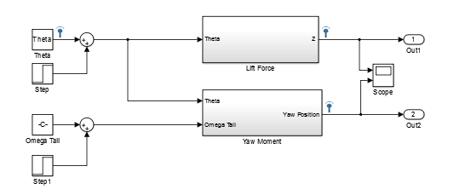
Block Diagram showing MIMO system
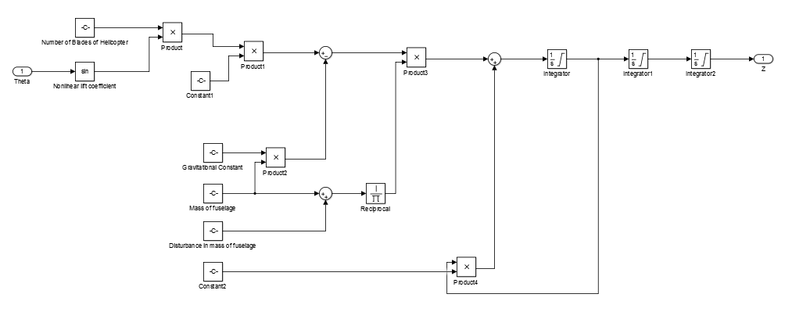
Block Diagram showing Lift Force Subsystem
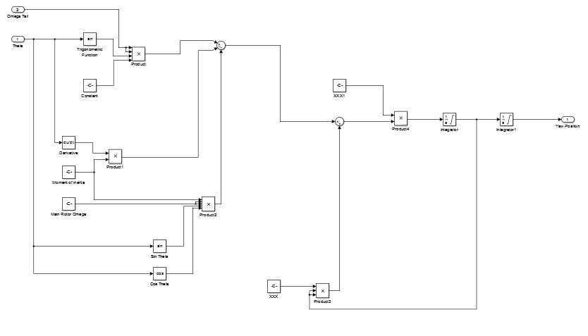
Figure Showing Yaw Moment Subsystem

A.1-Calculation of Equilibrium inputs
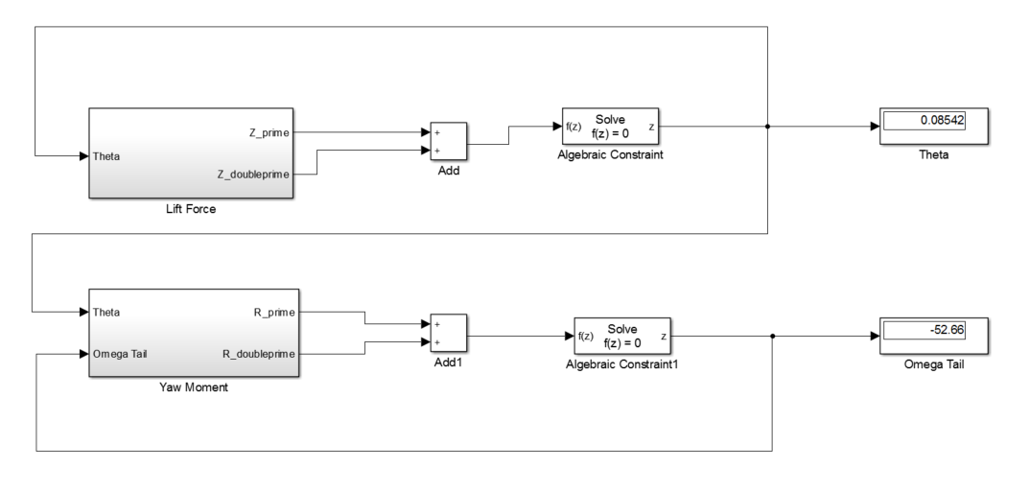

Raw Figures
$$∆m$$

$$θ$$
$$Z$$
F_{L} (ϴ)

$$R$$
L (ϴ, Ω_{T})
Ω_{T}

$$\left(\begin{matrix}R \\ \dot{R}\end{matrix}\right)$$
$$\left(\begin{matrix}Z \\ \dot{Z}\end{matrix}\right)$$

Z
ϴ
L (ϴ, Ω_{T})
R
Ω_{T}
ϴ
F_{L} (ϴ, β)

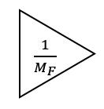
y₁ = R

u₁ = ϴ

$$\frac{12.64s^{2}}{-976s^{3}+s^{4}}$$

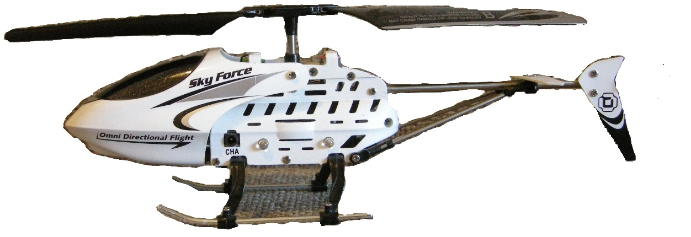
z
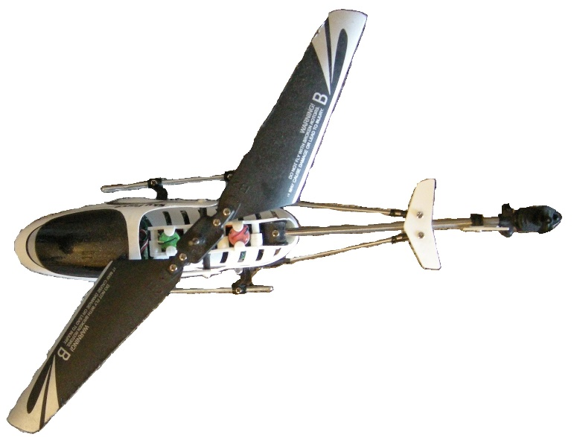

Mistakes / Extra Work
In this section, Taylor series expansions will be used to expand the nonlinear equations around an operating point, thereby linearizing the equations. One of the main assumptions that will allow the above nonlinear system to be linearized is the small angle assumption. Through this assumption the lift coefficient (C_{L}) and the sin(u₁) cos(u₁) terms will linearized. Since the blades will be assumed to rotate through small angles only, C_{L} can be approximated using a constant slope that will be defined by a. Next, since u₁ will be assumed to vary through small angles, the cos(u₁) term will go to 1 and the sin(u₁) will be approximated using the following Taylor Series expansion:
$\sin\left(x-δ\right)=\sum{(x-δ_{eq})-\frac{{(x-δ_{eq})}^{3}}{3!}+\frac{{(x-δ_{eq})}^{5}}{5!}+ϑ({(x-δ_{eq})}^{7})}$ Eq. 11
The above Taylor Series is expanded around an equilibrium operating point denoted by $δ_{eq}$. The only terms that will be kept in the above Taylor series expansion are the first order terms and all others will be dropped, so the $\sin\left(x-δ_{eq}\right)$ will be approximated as $x-δ_{eq}$.
Next, the nonlinear lift and drag (C_{L} and C_{D}) coefficients need to be linearized. Since the blades will only rotate through small angles, they are considered to stay within the linear region of the curves, and may be approximated by a constant slope times some maximum coefficient, a_{L} & a_{D}.
The last linearization that needs to take place is the linearization of the squared terms. Again, Taylor series expansion will be used to expand the term around and equilibrium point, $δ_{eq}$, and higher order terms will be dropped leaving a linear equation. The Taylor Series expansion of $f\left(x\right)=x^{2}$ about an equilibrium point $δ_{eq}$ is
$$\sum{{δ_{eq}}^{2}+2}δ_{eq}\left(x-δ_{eq}\right)+\frac{2}{2!}{\left(x-δ_{eq}\right)}^{2}$$
The second order term will be dropped.

To calculate a transfer matrix for the above linearized system we use the definition
$$H\left(s\right)=\overline{C}{(sI-\overline{A})}^{-1}\overline{B}$$
The resulting transfer matrix, H(s), obtained through matrix multiplication using Mathematica is
$$H\left(s\right)=\left(\begin{matrix}0 & \frac{12.64s^{2}}{-976s^{3}+s^{4}} \\ -\frac{33.345(-976s+s^{2})}{-976s^{3}+s^{4}} & \frac{0.506(-976s+s^{2})}{-976s^{3}+s^{4}}\end{matrix}\right)$$
The above transfer matrix is the linearized transfer matrix for the limited DOF helicopter system. The next step is to calculate the poles and zeros of the system. The poles of a MIMO system are defined to be the collection of poles for the individual entries in the transfer matrix. The zeros of a system are defined to be the zeros of the determinant of the transfer matrix. First, we will find the poles of the system. Looking at the individual entries, it can be seen that there is a common denominator of $-976s^{3}+s^{4}$. Factoring out a $s^{3}$ the equation factors to $s^{3}\left(-976+s\right)$. From this form, we see that the system has poles at s=976,0,0,0. A system is said to be stable if all the poles lie in the open left half plane, and the system of interest is extremely unstable with a pole at 976 (this is in agreement with the nonlinear simulations done in Simulink and the inherent characteristics of rotating blade flight). Next comes the issues of the zeros of the system. Zeros of a MIMO system are defined to be the zeros of the determinant of the transfer matrix. The determinant of the system is found to be
$$\left|H(s)\right|=\frac{421.76}{-976s^{3}+s^{4}}$$
It is not possible to solve $\left|H(s)\right|=0$, therefore we conclude that the system has no zeros (i.e. all frequencies are welcomed into the system).

determine which states are observable through which outputs. For this, the matrices $\left[\begin{matrix}λI-A \\ C_{1}\end{matrix}\right]$ and $\left[\begin{matrix}λI-A \\ C_{2}\end{matrix}\right]$ will be computed, where $C_{1}$ is defined to be the first row of the C matrix and $C_{2}$ is defined to be the second row of the C matrix.
$$\left[\begin{matrix}λI-A \\ C_{1}\end{matrix}\right]=\left(\begin{matrix}λ & -1 & 0 & 0 \\ 0 & -976+λ & 0 & 0 \\ 0 & 0 & λ & -1 \\ 0 & 0 & 0 & λ \\ 1 & 0 & 0 & 0\end{matrix}\right)$$

$$\left[\begin{matrix}λI-A \\ C_{2}\end{matrix}\right]=\left(\begin{matrix}λ & -1 & 0 & 0 \\ 0 & -976+λ & 0 & 0 \\ 0 & 0 & λ & -1 \\ 0 & 0 & 0 & λ \\ 0 & 0 & 1 & 0\end{matrix}\right)$$
Next, the respective values for $λ$ are substituted in and the rank of the resulting matrix is compared with the rank of the original Observability test matrix. Setting $λ=976$, the resulting matrices have a rank of 3. The fact that the rank of test matrices is less than the rank of the Observability test matrix, proves that the second state is not observable through either output (in agreement with the system!). The expectation is that the first and third states are observable. This can be proven by setting $λ=0$. The result gives us a $\left[\begin{matrix}λI-A \\ C_{1}\end{matrix}\right]$ with a rank of 4, and $\left[\begin{matrix}λI-A \\ C_{2}\end{matrix}\right]$ with a rank of 3, which is an indication that it is possible to observe one state through the first output, but not through the second.

As was done with the Observability matrix, additional matrices must be computed and their rank compared with the original Controllability matrix. $\left[\begin{matrix}λI-A & B_{1}\end{matrix}\right]$ and $\left[\begin{matrix}λI-A & B_{2}\end{matrix}\right]$ are the comparisons that will prove whether or not a state is controllable through one or both of the two inputs.
$$\left[\begin{matrix}λI-A & B_{1}\end{matrix}\right]=\left(\begin{matrix}λ & -1 & 0 & 0 & 0 \\ 0 & -976+λ & 0 & 0 & 0 \\ 0 & 0 & λ & -1 & 0 \\ 0 & 0 & 0 & λ & -33.35\end{matrix}\right)$$

$$\left[\begin{matrix}λI-A & B_{2}\end{matrix}\right]=\left(\begin{matrix}λ & -1 & 0 & 0 & 0 \\ 0 & -976+λ & 0 & 0 & 12.648 \\ 0 & 0 & λ & -1 & 0 \\ 0 & 0 & 0 & λ & 0.5069\end{matrix}\right)$$
From block diagrams constructed in the initial stages of model development, the expectation is that the first and second state will be controllable through the first input and the third and fourth state will be controllable through the first and second input. In order to confirm, $λ$ will be set equal to 0. The resulting matrices have a rank of 3, which means there is a state which has an eigenvalue of 0 that is not controllable through either output. Since there are three repeated poles, or eigenvalues of the system, the observability and controllability tests maybe inconclusive and it is not possible to get a clear picture of which states are controllable through which inputs. To get a general idea of whether or not the system is controllable the entire B matrix will be included in the Controllability test matrix as can be seen below.
$$\left[\begin{matrix}λI-A & B\end{matrix}\right]=\left(\begin{matrix}λ & -1 & 0 & 0 & 0 & 0 \\ 0 & -976+λ & 0 & 0 & 0 & 12.648 \\ 0 & 0 & λ & -1 & 0 & 0 \\ 0 & 0 & 0 & λ & -33.35 & 0.5069\end{matrix}\right)$$
Setting $λ=976$ and calculating the rank of the above test matrix, it can be shown that it has a rank of n=4, proving that the state with an eigenvalue of 976 is controllable. Testing the second eigenvalue of $λ=0$, the resulting matrix has a rank of n=4. Therefore, it can be said that the system is both observable and controllable.
$$\overline{C}=\left(\text{⁠}\begin{matrix}\frac{C_{D,F}*0.5*ρ_{air}*A_{F}}{M_{F}}*\frac{t^{2}}{2} & 0 & 0 & 0 \\ 0 & 0 & 0 & \frac{2*x_{4,eq}*C_{D,F}*0.5*ρ_{air}*2*A_{F}*\frac{D_{T}}{6}}{I_{F}}\end{matrix}\right)$$
$$\overline{D}=\left(\begin{matrix}\frac{N_{blade}*a_{L}*0.5*ρ_{air}*{(Ω_{m}*r_{m})}^{2}*A_{m}}{M_{F}}*\frac{t^{2}}{2} & 0 \\ \frac{a_{L}*0.5*ρ_{air}*{u_{2,eq}}^{2}*{r_{T}}^{2}*A_{T}*D_{T}+I_{B}*{Ω_{m}}^{2}}{I_{F}}*\frac{t^{2}}{2} & \frac{a_{L}*0.5*ρ_{air}*u_{1,eq}*2*u_{2,eq}*{r_{T}}^{2}*A_{T}*D_{T}}{I_{F}}*\frac{t^{2}}{2}\end{matrix}\right)$$
Plugging in values for the above variables, and assuming the solution does not vary with time, the numerical values for the matrix entries are calculated and shown below.
$\overline{A}=\left(\begin{matrix}0 & 1 & 0 & 0 \\ 0 & 976 & 0 & 0 \\ 0 & 0 & 0 & 1 \\ 0 & 0 & 0 & 0\end{matrix}\right)$ $\overline{B}=\left(\begin{matrix}0 & 0 \\ 0 & 12.6480 \\ 0 & 0 \\ -33.34 & 0.50687\end{matrix}\right)$
$\overline{C}=\left(\begin{matrix}0 & 488 & 0 & 0 \\ 0 & 0 & 0 & 1.952\end{matrix}\right)$ $\overline{D}=\left(\begin{matrix}6.3240 & 0 \\ 16.6729 & -0.021648\end{matrix}\right)$
The aim is to be able to control the system through the output, and in order to verify this is possible the system needs to be analyzed for Output Controllability. The output controllability matrix is given by
$$Q_{op}=\left[CB CAB CA^{2}B CA^{3}B D\right]$$
Plugging in the values for the A, B, C, and D matrices the result is
$$Q_{op}=\left(\begin{matrix}0 & 6172.263 \\ -65.091 & 0.989\end{matrix}\begin{matrix}0 & 6.024*{10}^{6} \\ 0 & 0\end{matrix}\begin{matrix}0 & 5.87*{10}^{9} \\ 0 & 0\end{matrix}\begin{matrix}0 & 5.73*{10}^{12} \\ 0 & 0\end{matrix}\begin{matrix}6.32 & 0 \\ 16.67 & -0.021\end{matrix}\right)$$
which has a rank of 2. The criteria of a system represented by y=Cx+Du; where D is (qxp) matrix, is that $Q_{op}$ must have a rank of q for the system to be completely output controllable. The rank of $Q_{op}$ calculated for the linearized helicopter system is 2 which is indeed equal to q=2! The system is completely output controllable.
In order to analyze the state controllability of the system, a similar matrix taking the form
$$Q_{o}=\left[B AB A^{2}B A^{3}B\right]$$
must be calculated. The resulting matrix is
$$Q_{o}=\left(\begin{matrix}\begin{matrix}0 & 0 \\ 0 & 12.64 \\ 0 & 0 \\ -33.34 & 0.5068\end{matrix} & \begin{matrix}0 & 12.64 \\ 0 & 12344.52 \\ -33.345 & 0.506 \\ 0 & 0\end{matrix} & \begin{matrix}0 & 12.648 \\ 0 & 1.2048×{10}^{7} \\ -33.345 & 0.506 \\ 0 & 0\end{matrix} & \begin{matrix}0 & 12.64 \\ 0 & 1.1759×{10}^{10} \\ -33.345 & 0.50 \\ 0 & 0\end{matrix}\end{matrix}\right)$$
having a rank of 4. The determinant of submatrix is $≠0$, therefore the system is not state controllable.
The transfer function of the system was found using the MATLAB command [num, den]=ss2tf(A, B, C, D), where $H\left(s\right)=\frac{NUM}{DEN}=C{(sI-A)}^{-1}B+D$. The following result was found:
$$\left(\begin{aligned}Y_{1} \\ Y_{2}\end{aligned}\right)=\left(\text{⁠}\begin{matrix}\frac{6s^{4}-6172s^{3}}{s^{4}-976s^{3}} & \frac{6172s^{3}}{s^{4}-976s^{3}} \\ -\frac{17s^{4}-16273s^{3}}{s^{4}-976s^{3}} & \frac{21s^{3}}{s^{4}-976s^{3}}\end{matrix}\right)\left(\begin{matrix}u_{1} \\ u_{2}\end{matrix}\right)$$
With
$$H\left(s\right)=\left(\text{⁠}\begin{matrix}\frac{6s^{4}-6172s^{3}}{s^{4}-976s^{3}} & \frac{6172s^{3}}{s^{4}-976s^{3}} \\ -\frac{17s^{4}-16273s^{3}}{s^{4}-976s^{3}} & \frac{21s^{3}}{s^{4}-976s^{3}}\end{matrix}\right)$$

The above transfer matrix can be rewritten in simplified form as:
$$H\left(s\right)=\left(\text{⁠}\begin{matrix}\frac{-316}{-976+s} & \frac{6172}{-976+s} \\ \frac{-32865}{-976+s} & \frac{21}{-976+s}\end{matrix}\right)+\left(\text{⁠}\begin{matrix}6 & 0 \\ -17 & 0\end{matrix}\right)$$

The next step is to calculate the poles and zeros of the system. The poles of a MIMO system are defined to be the collection of poles for the individual entries in the transfer matrix. The zeros of a system are defined to be the zeros of the determinant of the transfer matrix. First, we will find the poles of the system. Looking at the individual entries, it can be seen that there is a common denominator of $-976s^{3}+s^{4}$. Factoring out a $s^{3}$ the equation factors to $s^{3}\left(-976+s\right)$. From this form, we see that the system has poles at s=976,0,0,0. A system is said to be stable if all the poles lie in the open left half plane, and the system of interest is extremely unstable with a pole at 976 (this is in agreement with the nonlinear simulations done in Simulink and the inherent characteristics of rotating blade flight). Next comes the issues of the zeros of the system. Zeros of a MIMO system are defined to be the zeros of the determinant of the transfer matrix. The determinant of the system is found to be
$$\left|H(s)\right|=\frac{401760}{-976s+s^{2}}$$
It is not possible to solve $\left|H(s)\right|=0$, therefore we conclude that the system has no zeros (i.e. all frequencies are welcomed into the system).
Part 3.3.1: Matrix Transformations
In order to check the controllability and observability of the system it is necessary to know the rank of the A matrix in Diagonal/Jordan Canonical Form. Using the “canon” command in MATLAB, the system is transformed into a block-diagonal matrix. The blocks are 1x1 for real eigenvalues. The system below is found using the above procedure.
$\overline{A}=\left(\begin{matrix}0 & 1 & 0 & 0 \\ 0 & 976 & 0 & 0 \\ 0 & 0 & 0 & 4 \\ 0 & 0 & 0 & 0\end{matrix}\right)$ $\overline{B}=\left(\begin{matrix}0 & - \\ 0 & - \\ 0 & 0 \\ - & -\end{matrix}\right)$
$\overline{C}=\left(\begin{matrix}1 & 0 & 0 & 0 \\ 0 & 0 & 1 & 0\end{matrix}\right)$ $\overline{D}=\left(\begin{matrix}0 & 0 \\ 0 & 0\end{matrix}\right)$
The dimension of matrix $\overline{A}$ above is q=4, which will be used in the following section to determine the controllability and observability.
Part 4.1: Single Input Single Output Control
In the sections above, a nonlinear system has been modeled, it was linearized, analyzed for stability, controllability and observability. The steps leading up to this section have all been in preparation to design controllers that will make the system operate at desired steady state conditions with desired transient responses. Eventually, the hope is to design a controller that will control all desired states, however, in this section a SISO case using the (1,1) entry of the transfer matrix will be used to design a controller.
The transfer function of interest for this case is $H\left(s\right)=\frac{-316}{-976+s}$, having a pole at 976. The system is extremely unstable as the pole is in the far right hand plane. The ultimate goal of the controller is to be able to track a sinusoid which takes the form $\frac{1}{s^{2}+1^{2}}$, the chosen sinusoid has a frequency of 1 Hz. The controller will be of the form $\frac{β_{1}s+β_{o}}{s{+α}_{o}}$
- Determine the characteristic equation of the closed-loop transfer function
$$∆s=nc*np+dc*dp$$
$$=\left(β_{1}s+β_{o}\right)\left(-316\right)+\left(s{+α}_{o}\right)\left(-976+s\right)$$
$$=\left(-316β_{1}s-316β_{o}\right)+\left(s^{2}-976s-976a_{o}+a_{o}s\right)$$
$$=s^{2}+s\left(-976-316β_{1}+a_{o}\right)+\left(-316β_{o}-976a_{o}\right)$$

The Sylvester Matrix form of the above equations is:

$$\left(\begin{aligned}δ_{1} \\ δ_{0}\end{aligned}\right)=\left(\begin{matrix}1 & -316 & -316 \\ -976 & 0 & -316\end{matrix}\right)\left(\begin{aligned}a_{o} \\ β_{0}\end{aligned}\right)-\left(\begin{aligned}976 \\ 0\end{aligned}\right)$$

$β_{1}$ is free to chosen to assume any value, and the resulting values of $a_{o}$ and $β_{o}$ will change depending on the chosen value. For the purposes of the control system for the helicopter, $β_{1}$ is chosen to be 1.

If we place the poles at s=-976, the resulting desired characteristic equation is ${∆s}_{desired}=s^{2}+1952s+952576$. Again, solving for the unknown controller coefficients using the Sylvester Matrix method, the resulting values are:
$$β_{o}=-13033.9$$
$$β_{1}=1$$
$$a_{o}=3244$$

Once again the system was simulated in Simulink with a step function change, and the resulting plot was generated:
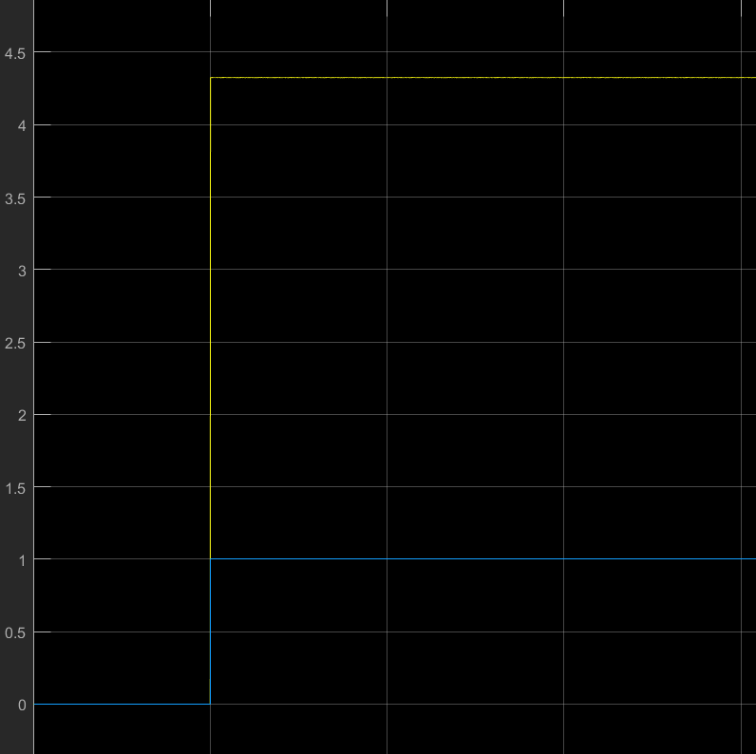
Figure 9 - SISO Controller with step input
From the above figure, it can be seen that there is a steady state error associated with the controller and pole locations chosen above.

Another iteration was done and the poles were chosen to live at s=-31232. The resulting values for the coefficients were found to be:
$$β_{o}=-2900820$$
$$β_{1}=1$$
$$a_{o}=60224$$
The controller was simulated using Simulink, and a step input.
Figure 10 – Tuned SISO Controller tracking step input
Again, there is a steady state error associated with controller. A sinusoid of frequency 1 Hz was used as an input and fed into the system to analyze the ability of the controller to track an oscillating signal.
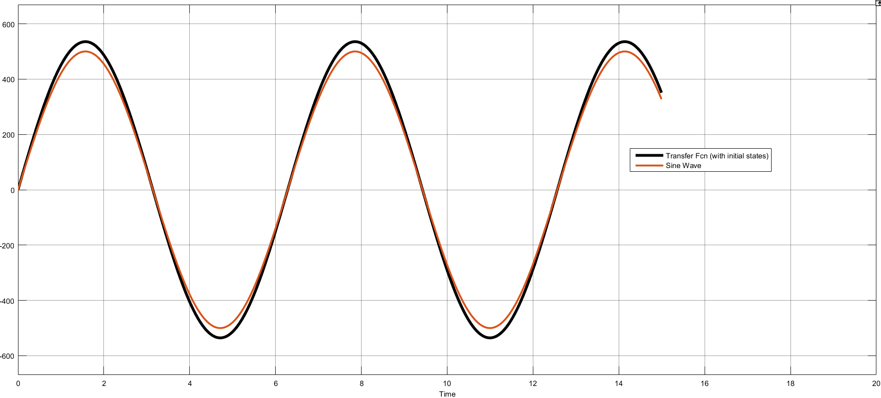
As can be seen above the controller tracks the signal, but there is some steady state error apparent between the reference signal and the plant output. It is possible the controller doesn’t have the correct order to a new controller will be designed taking the form:
$$C\left(s\right)=\frac{β_{2}s^{2}+β_{1}s+β_{0}}{s^{2}+α_{1}s+α_{0}}$$
The characteristic equation for the closed loop system is:
$$∆s=nc*np+dc*dp$$
$$=\left(β_{2}s^{2}+β_{1}s+β_{0}\right)\left(-316\right)+\left(s^{2}+α_{1}s+α_{0}\right)\left(-976+s\right)$$
$$=\left(-316β_{2}s^{2}-316β_{1}s-316β_{0}\right)+\left(s^{3}{+α}_{1}s^{2}-976s^{2}-976α_{1}s+a_{o}s-976a_{o}\right)$$
$$=s^{3}+s^{2}\left(-316β_{2}{+α}_{1}-976\right)+s\left(-316β_{1}-976α_{1}+a_{o}\right)+\left(-316β_{0}-976a_{o}\right)$$

The Sylvester Matrix Form of the above equation is:
$$\left(\begin{aligned}δ_{2} \\ δ_{1} \\ δ_{0}\end{aligned}\right)=\left(\begin{matrix}1 & 0 & 0 \\ -976 & 0 & -316 \\ 0 & -316 & 0\end{matrix}\right)\left(\begin{aligned}a_{1} \\ β_{0} \\ β_{1}\end{aligned}\right)-\left(\begin{aligned}-976 \\ 0 \\ 0\end{aligned}\right)$$
The $α_{0}$ and $β_{2}$ terms can be chosen arbitrarily and the values of the rest of the coefficients will be solved with the chosen values. For the first iteration, the poles will be chosen to live at s=-500. The desired characteristic equation is ${∆s}_{desired}=s^{3}+1500s^{2}+750000s+125000000$. Solving for the values
$$β_{o}=-395573$$
$$β_{1}=-10996.8$$
$$β_{2}=1$$
$$a_{1}=2792$$
$$a_{0}=1$$
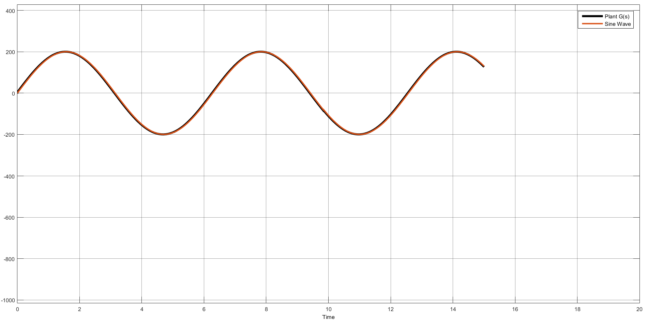
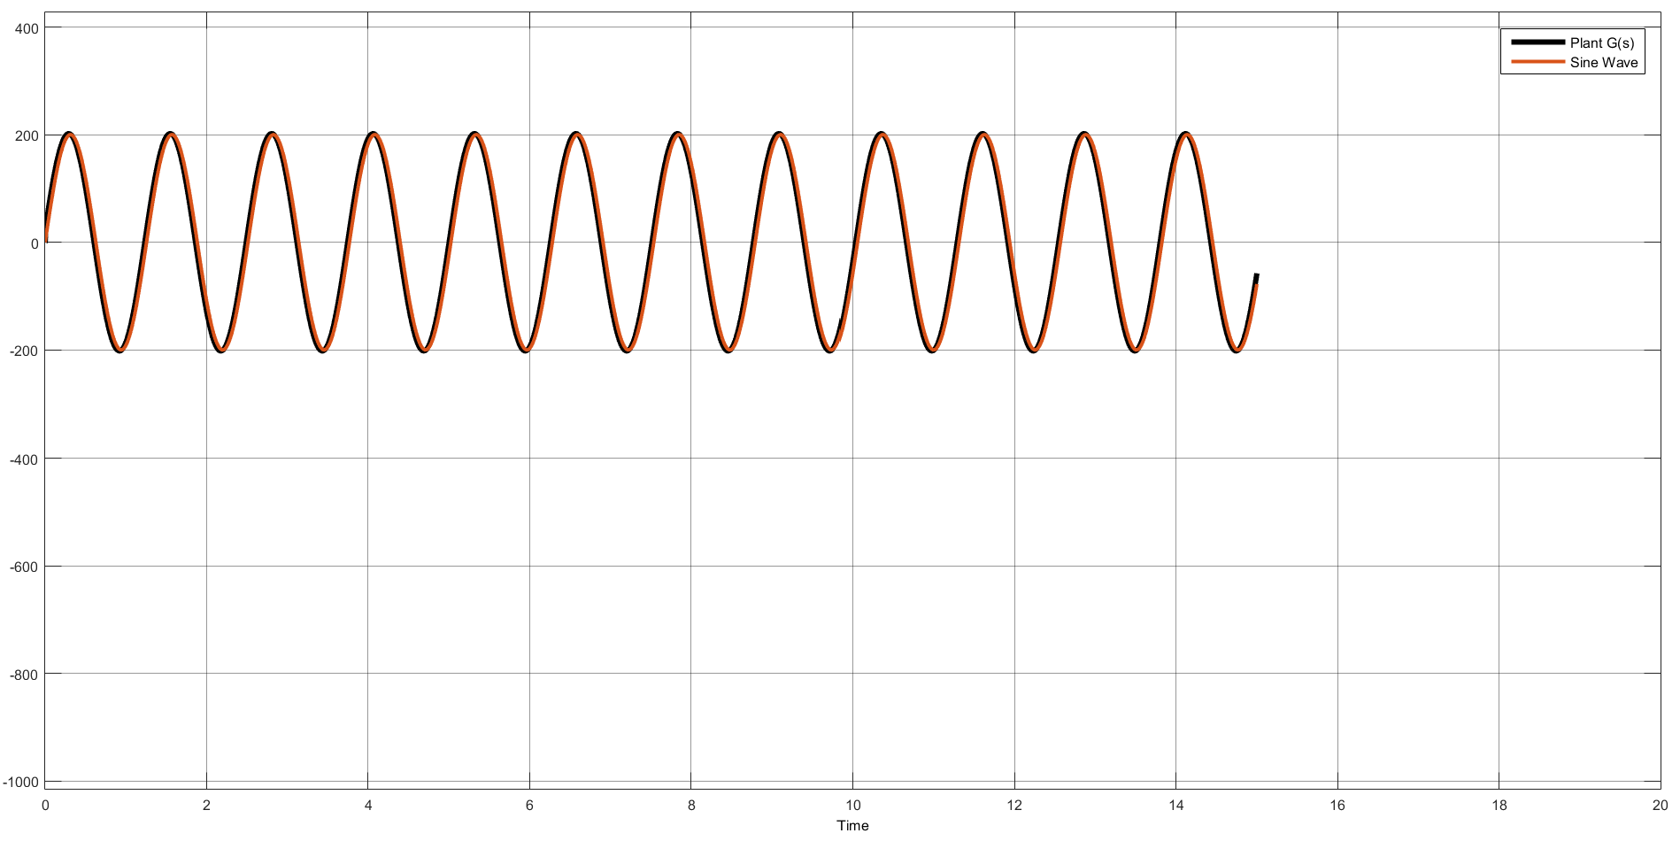
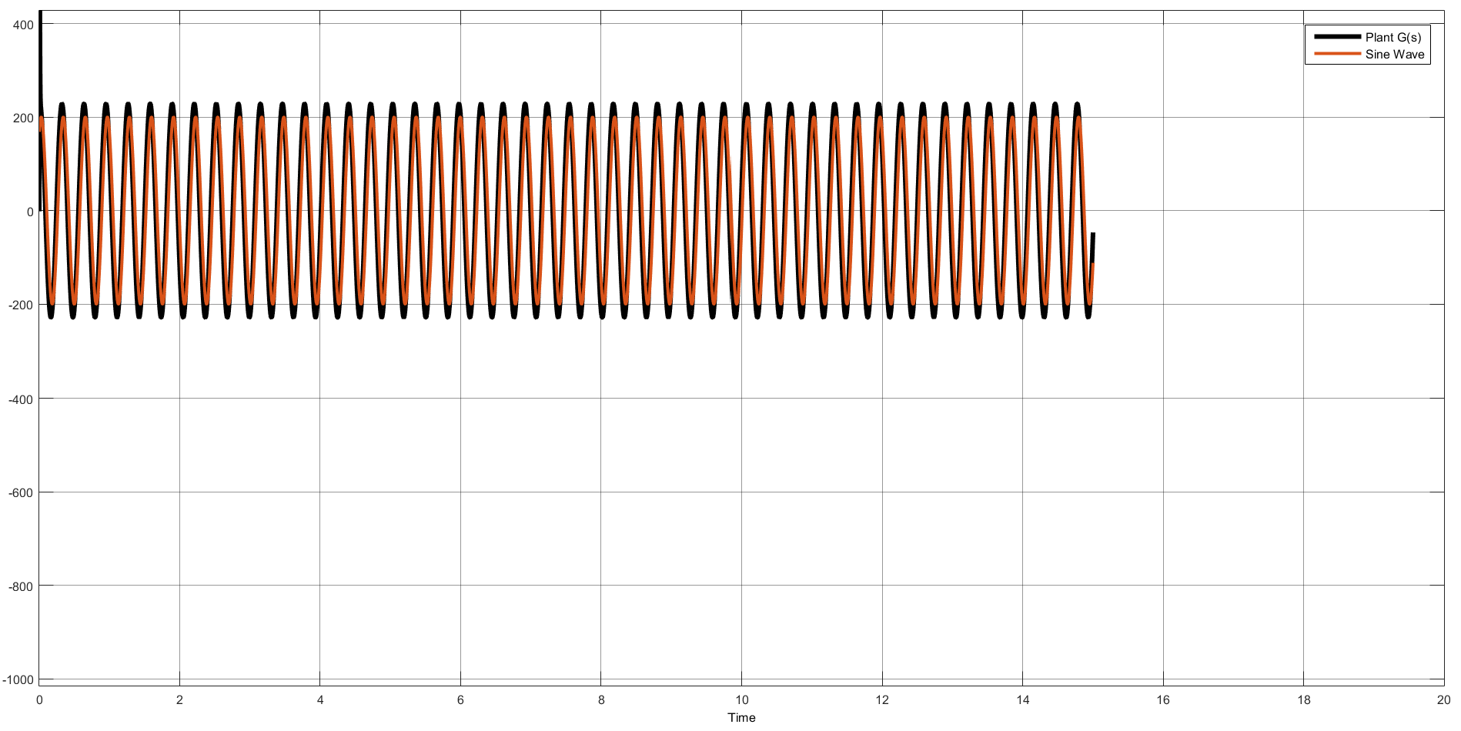
The Figure above shows that the controller can successfully track a sinusoid with 0 steady state error at various frequencies!

